Group Report
Introduction
This report will explain and analyse the design process of the project our group has undertaken. The project we have collectively chosen is Project 1: Command-Line Inventory Management System. Our group must create a command-line application to help a small business owner track product inventory.

We consist of 6 members including Tolulope Akinrinlola, Charlie Millington, Erin Rayworth, Harrison Bonney, Haillie Tiger Lyons, and Rhys Jones. Our team has equally allocated roles and each member will contribute equally to all or most aspects of the project.

This report will consist of multiple sub-sections consisting of:
==========================================================================
System Design
Explain the design process and illustrate the main logic of our application, describing both the data structures and file formats.
==========================================================================
Implementation Summary
This section will discuss key implementation details and technical decisions that have been made by our team to better the project. Any unexpected or significant challenges that were encountered will also be highlighted, outlining both the problems we were troubled with and the solutions we devised to deal with these problems.
==========================================================================
Testing
A comprehensive test plan that provides clear and concise evidence of testing that was carried out by our team. The test plan consists of the inputs used and the resulting outputs, The predicted output vs the actual output we were met with, along with screenshots that clearly evidence these tests.
==========================================================================
Contributions
This section provides a constructive breakdown of the contributions made by each member of our team delivered in list format. This allows fairness during the project ensuring all members of the project make valid and useful contributions.
==========================================================================
Reflection
This area of the report is a reflective analysis of the teamwork of our team and how teamwork contributed to the better completion of the project. It will also discuss the positives and negatives of what went well and what went wrong with the processes and decisions made, taking into consideration what could have been done differently. What can be done differently next time and reflect on how we as a team managed the collaboration.
==========================================================================

==========================================================================
Conclusion
Finally, the conclusion of this report summarises the project as a whole, outlining and discussing both the stepping stones and the achievements that have been made during the life of the project that resulted in its completion.
==========================================================================

System Design
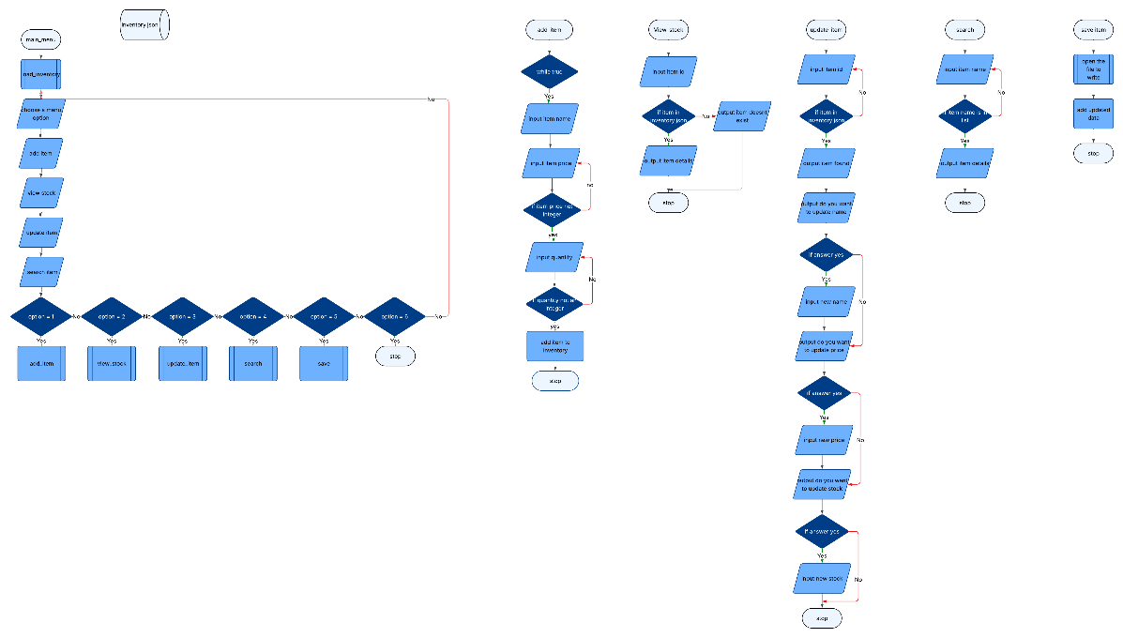

Implementation Summary
During the lifetime of the project, our team made many technical decisions to improve the overall outcome of the project and to also overcome certain challenges we faced. As a group we divided the code-building as equally between us as we could to ensure a single person was not encumbered with much more work than others as this could result in problems and human error. Another technical decision that was made by our team to improve the project was to only fix the mistakes that were in the code after the whole code was brought together to prevent changes to the code at the same time from clashing with one another. By testing and correcting the errors in the code after the individual codes where brought together, it allowed each member to download a separate copy of the complete code and work on their own testing and solutions without changing or disturbing the testing and problem solving of another member. However, during the project we faced minimal challenges that were easily fixed with so alterations to code such as misspellings and incorrect lines of code. Many members of the team ensured all code was correct by conducting thorough and repeated testing each time a new article of code was added allowing for efficiency and preventing unknown or unseen errors from surfacing later on in the project.

Testing
Feature | Test description | Test steps | Expected result | Actual result | Pass/fail | Comment on fix
First time running | Running the program for the first time to see if it works | Run  Main menu displays | The program runs without any errors and works correctly | The program runs and the main menu is displayed | Pass | N/A
Testing add item function | Selecting the add item feature | Run the program  Press 1 to access function | That the program runs and add item works | The function works | pass | N/A
Testing adding an item | Entering item to add to the function | User enters item, price and quantity | The program adds the item and all data to the json file | An error happens  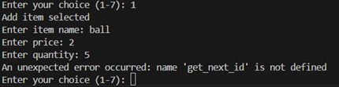 | Fail | Add get_next_item function  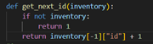
Testing adding item again | Enter item to the add function | User enters item, price and quantity | The program adds the item and all data to the json file | It runs correctly | pass | N/A
Check if item is added to json | Enter item to the add function | User enters item, price and quantity | The program adds the item and all data to the json file | The item isn’t added to the file | fail | Fix function to add item  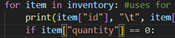  Stock had to be changed to quantity in view_stock and update_item
Check if item is added to json | Enter item to the add function | User enters item, price and quantity then press 5 to save item | The program adds the item and all data to the json file | The data is added to the file | pass | N/A
Testing view stock | Enter menu option to display items and their stock | Press 2 on main menu | The stock and items names are displayed | The stock and item names are displayed  But so is the total amount of all stock added which isn’t needed | pass | Delete total stock from the function
Testing view stock | Enter menu option to display items and their stock | Press 2 on main menu | The stock and items names are displayed and no total stock | The stock and item names are displayed  Total stock isn’t displayed | pass | N/A
Test update item | Enter menu option 3 to update the stock | Press 3 on main menu then enter product id, price update and stock amount then press 5 to save | The product id entered should be found, price should then be updated based on amount entered, same with stock. | The items are updated after save is pressed | pass | N/A
Test select item | Enter menu option to search through list | Enter 4 on the menu | The program should go through the search function | The function loads correctly | pass | N/A
Test input on search | Enter item wanting to be searched | User enters input | The program should accept input if correct and display item details | The function works correctly | pass | N/A
Test input on search | Enter item wanting to be searched | User enters input | The program should accept input if correct and display item details | The function works correctly | pass | N/A
Test main menu | Check user input is valid and not outside the allowed options | Test negative input isn’t accepted | The program should return an error and ask user to input again | The error is returned | pass | N/A
Test main menu | Check user input is valid and not outside the allowed options | Test input above 7 | The program should return an error and ask user to input again | The error is returned | pass | N/A
Checking price input | Check user can only enter an integer or float | Test a string input | The program should return an error | An error is returned saying invalid input, but program then returns to main menu instead of asking again | pass | Change so program loops back to ask user again  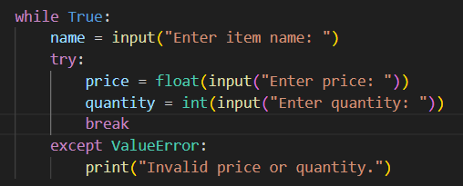  Add while loop to fix
Checking price input | Check if user input invalid price and loops to ask question again if users’ input is incorrect | Test string input | The program should return an error and then ask again. | It works and asks user to input item again. | pass | N/A
Check stock number input | Check if user input is valid and is an integer if not loops to ask the question again | Test integer input | The program should return an error and then loop to ask again | It works and asks user to input again | pass | N/A

Contributions

Haillie:
- Contributed 2 functions - update_item() and view_stock()
- Merged teammate’s code from separate files into main.py
- Formatted all code to make clear which function related to which available option
- Structured main.py overall so remaining incomplete functions could be inserted in place
- Enabled all new functions in if-statements
- Amended low_stock_report() if-statement as it hadn’t been functioning as intended
- Created data for inventory.json
- Formatted teammate’s output code for visual consistency, and commented code for clarity
- Contributed reflection portion of Group Report

Charlie:
- Created group report introduction,
- Created the code for the add_Item function as well as the append.
- Created code for the low_stock_report, one of the extra/optional parts of code to improve the code/project.
- Completed the Implementation summary of the group report.
- Completed did a test of the code I completed e.g add_item function
- fixed a duplication of code

Rhys:
- Contributed search item function
- Built main inventory system for search
- Added main management features for search
- Created a menu interface and included a search option

Erin:
- Built main menu to allow group to add their functions
- Tested and documented code and changes when finished
- Fixed any of the code that was broken during the testing stage then checked over to make sure no logic errors remained
- Deleted duplicated functions
- Created the flowcharts for the program
- Contributed to testing, reflection and conclusion of project

Reflection

Our team met the requirements of the project successfully with few errors or disagreements. However, our communication was initially inconsistent and infrequent, likely due to the group not having met before being joined together – this led to confusion for some group members as we were initially uncertain of what work was available to be done. Further down the line, this miscommunication caused some duplication of work. However, the team did show good overall working together later on, as the program was put together with full group contribution in a short time span. The team also swiftly dealt with issues regarding duplication or confusion with no disagreement or negativity. In addition, some of our team members were proactive in choosing to work on the extra tasks when they had finished their parts and this was supported by the rest of the group.

In retrospect, the team may have benefitted from dedicating meeting time earlier in the process, which could have encouraged clearer communication and more confident discussion of how to proceed. Despite this, the group overall showed dedication enough to overcome these issues and create a program which exceeded base requirements.

Conclusion
In conclusion, this project successfully met the requirements of the command-line inventory management system described in the project brief. The program uses a JSON file to store inventory data, allowing information to be loaded when the program starts and saved after changes are made. This ensures that stock data is kept between sessions, which is important for managing products accurately.

The system allows users to add, view, update, and search for items through a clear and easy-to-use menu. All main inventory operations are handled using a list of dictionaries, showing effective organisation of data and logical program structure. The program also includes input checks and error handling to manage incorrect user input, missing files, and other common errors, making it more reliable and user-friendly.

An extra feature, the low-stock report, improves the system by helping users identify items that may need restocking. Overall, the project demonstrates a good understanding of Python basics, file handling, and simple user interface design, resulting in a functional and dependable inventory management system that meets the goals of the project brief.

